Liebherr moisture measurement system FMS
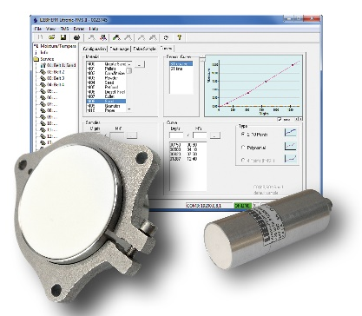

Customer: |  | Contact:
Address: |  | Phone:
E-mail: |  | Date:
Website:

Material characteristics:
Material to be measured:
Composition description:
 | Homogeneity:
Is metal present: | yes no content %  Variation:
Powder & Bulk: | Other Powder&Bulk:  Grain size:  min: mm max: mm
Emulsion/other description: | Other emulsion:  density:  approx. g/cc (kg/dm³) Variation:
Measuring range, moisture: min: % max: %
Water saturation at: approx. % moisture

Required accuracy: +/- %
Product abrasiveness: low high

Product “stickiness”: low high
Product conductivity: yes no

Moisture reference (%moisture):

Ambient conditions:
Process temperature: min: °C max: °C
Ambient temperature: min: °C max: °C
Material layer on sensor: min: mm max: mm
Further information (e.g.: SIP, CIP):
(Food Grade level required (what level?):
Type of washdown used:
Installation:
Installation place: Tube : mm
Other

Process type: Continuous operation Batching operation (Starting signal 24V)
Distance from the sensor location/s to the controller: feet or meters
Max range is 1,200 meters´- 3,900 feet total installed in series via optional RS-485 bus cable)

Number of measuring points / sensors heads: (max. 16 sensor heads per controller
interchange and evaluation unit)

Interchange and evaluation unit:
Desired interface to customer from the controller-interchange unit:

EX-protection
separate process display necessary
Brief description of the plant process and goal for In-Line measurements:

